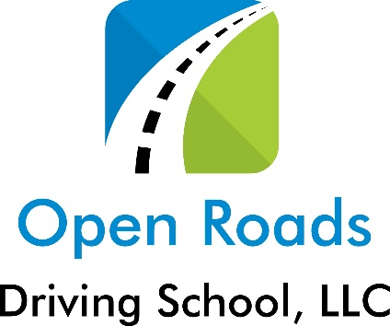
Open Roads Driving School, LLC.
www.openroadsdrivingschool.com
Course Registration/Agreement

Contract #____________ Date ______
Name____________________________ DOB ________
Last first MI
Address __________________________________
City/ State/Zip _____________________________
Ph#-Home _____________Cell _______________email ________________
Lesson Type- Classroom only- ------------------------------$
Classroom/BTW- 6/6------------------------$
Hybrid Classroom/BTW- -------------------$
BTW Only----------per lesson---------------$
Online Classroom/BTW---------------------$
Open Roads Driving School, LLC. (ORDS) will not refund any tuition if ORDS is ready, willing and able to fulfill its part of the agreement. This written agreement constitutes the entire agreement between ORDS and the student/parent or customer and no verbal statement or promise will be recognized. ORDS reserves the right to charge a $40 missed appointment fee for any behind the wheel lesson not cancelled at least 8 hrs in advance of the scheduled appointment time. $10 BTW Fuel surcharge may apply if pump price over $3.75
Cust./Student ____________________Parent /Guardian ________________
Owner/Agent OPDS_________________ Deposit/Paid _________ Date_________

